Jose Rodriguez
6/7/2026
CSD310 Module 1.2 Assignment

https://github.com/jrod818/csd-310.git
Screenshot of configured Git
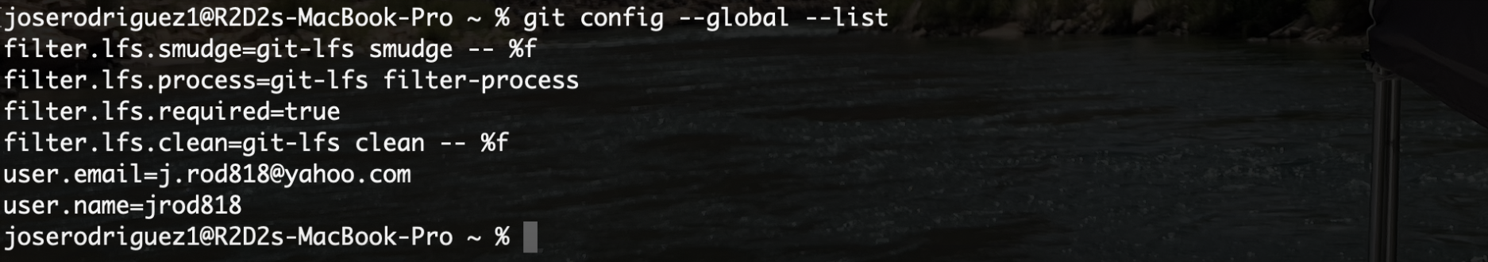
Screenshot of local directory
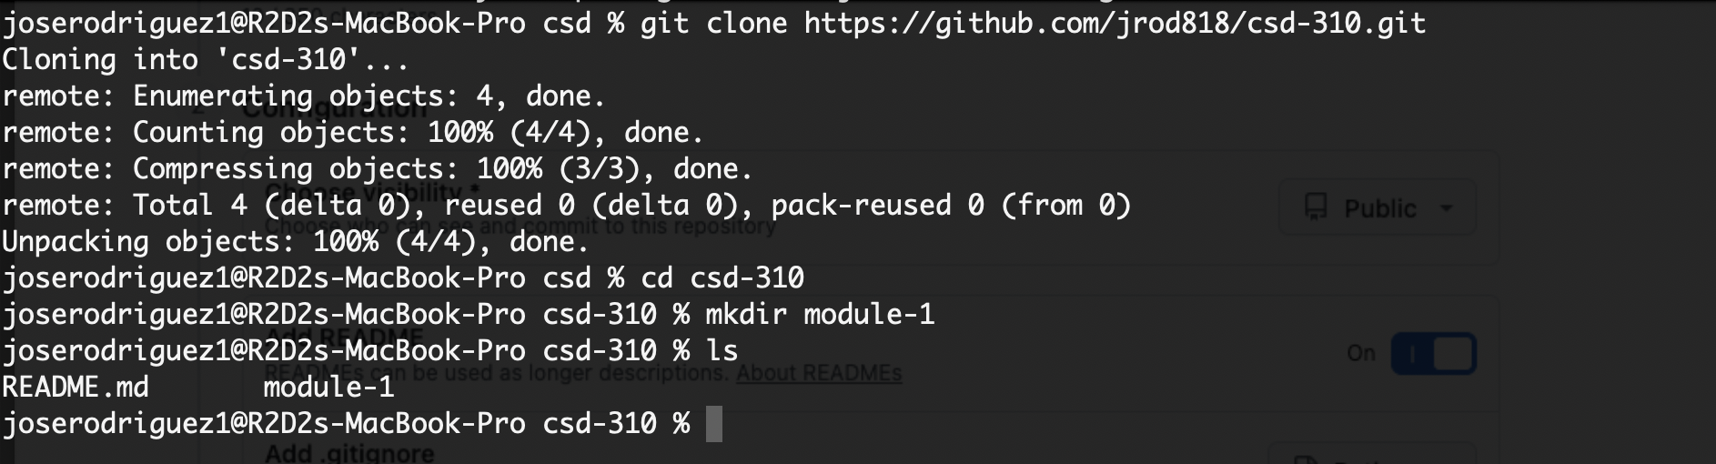
Screenshot of GitHub repository
